**Project**

**VIEWSPACE**

Lesnic Dumitru, MI21Z

**Сontent**

1. Short description 4

1.1 Introduction 4

1.2. Registration and Orientation 4

1.3. What is ViewSpace? 4

1.4. Interactives 4

1.5. Gallery 4

2. ToR 5

2.1. Project Overview 5

2.2. Objectives 5

2.3. Scope of Work 5

2.4. Deliverables 5

2.5. Timeline 6

2.6. Budget 6

2.7. Team Responsibilities 6

2.8. Contact Information 6

2.9. Confidentiality 6

3. Requirements 6

3.1. UI/UX - Colors 6

3.2. Browsers, devices and resolutions 6

4. Web site structure 7

4.1. Navigation Bar 7

4.1.1. Home 7

4.1.2. Interactives 7

4.1.3. Gallery 7

4.1.4. Venue Login 7

4.2. Main page 7

4.3. Footer 8

4.3.1. Contact Us 8

4.3.2. About 8

4.3.3. F.A.Q 8

4.4 First screen - Into 8

5. Project duration and timelines 8

# Short description

## 1.1 Introduction

## Title: "ViewSpace: EXPLORE THE UNIVERSE"

## The Universe and space have always been inaccessible but desirable areas for human exploration. Now, in the era of modern technologies and new opportunities, we can join this.

## 1.2. Registration and Orientation

## Welcome to the popular science and general educational project ViewSpace, dedicated to the study of cosmology and astrophysics! This project was created for traveling to places you could only dream of. Get ready to plunge into the depths of our universe, study its patterns and paradoxes and gain new knowledge!

## 1.3. What is ViewSpace?

## ViewSpace is a free, web-based collection of digital interactives highlighting the latest developments in astronomy and Earth science.

## 1.4. Interactives

ViewSpace interactives allow you to explore objects and materials from different perspectives, discovering how we can combine information to better understand the universe.

## 1.5. Gallery

ViewSpace gallery tell the stories of the planets, stars, galaxies, and universe, giving viewers the opportunity to experience space and Earth as seen with satellites and telescopes.

**Conclusion:** Immerse yourself in a journey through the universe with ViewSpace

# ToR

## 2.1. Project Overview

## The purpose of this document is to outline the Terms of Reference (ToR) for a research and development project aimed at studying, explaining and presenting data about space in an interactive format.

## 2.2. Objectives

## The main objectives of the project are:

## - Development of interest among users in scientific data about space.

## - Consistent explanation and disclosure of extraterrestrial phenomena through simple presentation of information.

## - Creation and development of the idea among people that cosmology and astrophysics are interesting.

## - General educational goals in the accumulation and use of information among enthusiasts and hobbyists.

## 2.3. Scope of Work

The project shall be open to all individuals, regardless of their level of expertise.

Design and development of a custom website with [] number of pages.

Integration of [], such as a contact form, blog, and social media links.

Creation of visually engaging graphics and multimedia elements.

Content management system (CMS) integration for easy content updates.

SEO optimization for improved search engine rankings.

## 2.4. Deliverables

Fully functional website with all specified features and pages.

## 2.5. Timeline

The project is expected to be completed by [].

Regular progress updates and milestones will be established throughout the project.

## 2.6. Budget

## 2.7. Team Responsibilities

## 2.8. Contact Information

[lesnicdmitrii@gmail.com](mailto:lesnicdmitrii@gmail.com)

## 2.9. Confidentiality

All project-related information and materials are considered confidential and should not be disclosed without proper authorization.

## Requirements

## 3.1. UI/UX - Colors

Main colors:

* Gray
* Black
* Green

## 3.2. Browsers, devices and resolutions

Browsers:

* Opera
* Google Chrome

Devices:

* PC
* Mobile devices

Resolutions:

* PC
  + From full HD to 8K
* Mobile devices
  + Width from 300 to 600

# Web site structure

## Navigation Bar

### 4.1.1. Home

This link would redirect users to the main page of the mathematical forum.

### 4.1.2. Interactives

### This section will present a list of various interactives that the user interacted with and will be presented with data

### 4.1.3. Gallery

### This section will present a list of various images of the universe taken using modern telescopes

### 4.1.4. Venue Login

These options would enable users to create an account or log in to their existing account to participate in the space exploration in more detail.

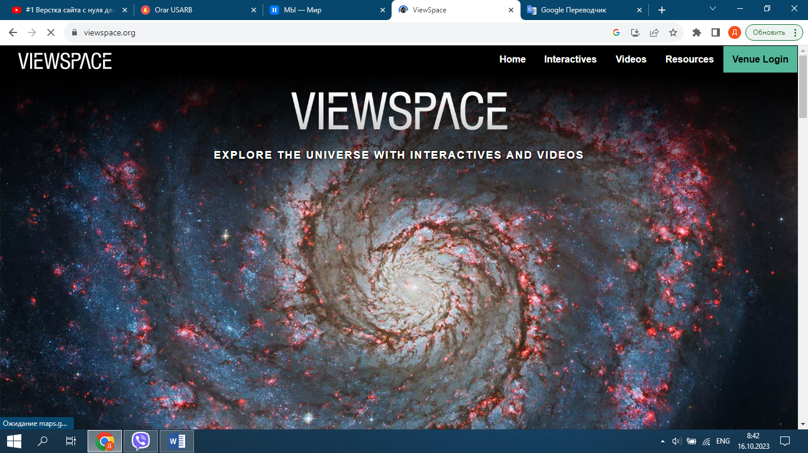

## Main page

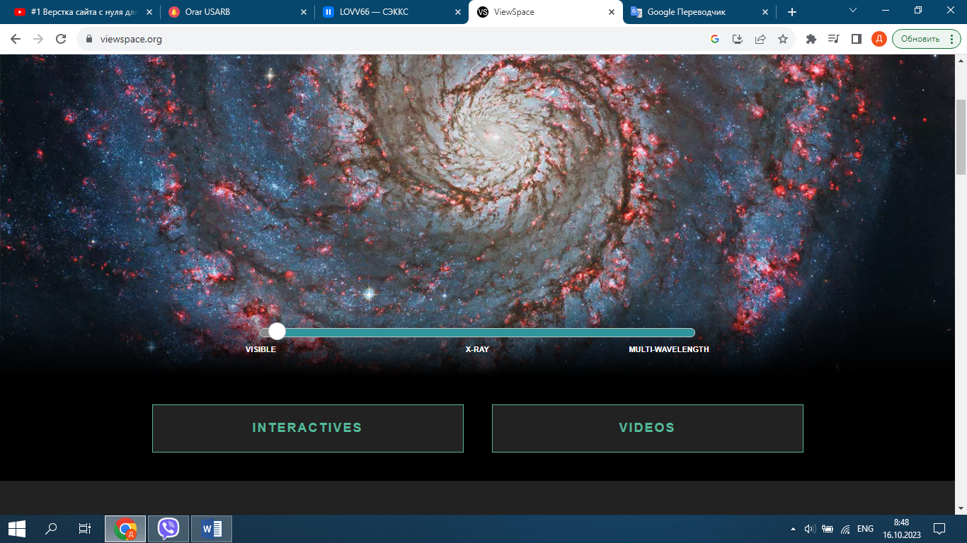

## Footer

### 4.3.1. Contact Us

### This section is intended for communication with developers through a user-created account

### 4.3.2. About

This link would provide information about the project, including its purpose, mission.

### 4.3.3. F.A.Q

A platform for users to present a question to developers

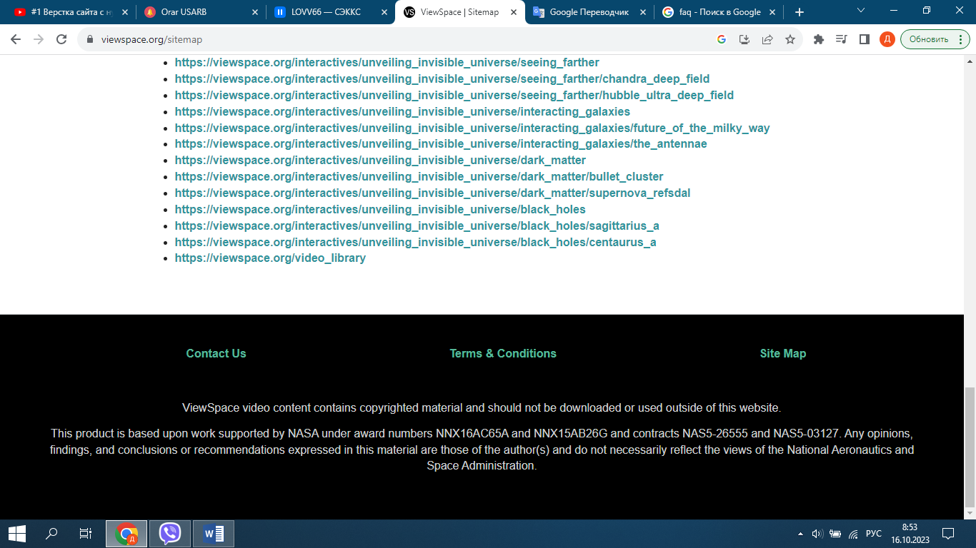

## 4.4 First screen - Into

Smth like this:

## <https://viewspace.org/>

# Project duration and timelines

Project will start: 24.09.2023

Project deadline: xx.xx.2023

**24.09.2023 - 05.10.2023 - Design**

Develop a modern, responsive, and mobile-friendly website.

Improve user experience and navigation.

**08.10.2023 - 20.10.2023 - Main page. Content management**

Information will be added to the site. Information will be provided by the custom